Beverage Vending Machine Documentation Template Paper

CSC 414 Software Design

Cody Ezell

Due: 11/3/20

1. **– Introduction**

This document outlines the specifications and details on the use and functionality of the Beverage Vending Machine software version 1.0 using the Python3 language. The software is designed to implement a software-strict output rather than using hardware to vend a physical can of beverage, which can later be refined to implement hardware that will dispense a physical beverage using a physical machine.

**1.1 – Program Purpose**

The purpose of this software is to allow the user to make a selection on which beverage they would like to dispense given the user has met the monetary requirement for the price of the beverage. The program will then display the price for each beverage and request the user to pay the designated price before the system will output the beverage. If the user has inputted more money that the price of the beverage, then the system will dispense the difference to the user. If the user has not inputted enough money to meet the price requirement, the system will display the remaining balance needed before the machine will dispense a beverage. The system is also designed to display the picture of the selected beverage in replacement of an actual drink bottle being dispensed.

**1.2 – Document Overview**

The outlined document provides a brief overview into what the system is and how it is intended to perform in section 1.0, citations and descriptions into the references used for implementing certain algorithms and packages within the system in section 2.0, the requirements that are to be met to be considered a complete and optimal system in section 3.0, the design implementation that was used in formatting and laying out the code as well as the GUI in section 4.0, testing overview found in section 5.0, and finally the table that describes the user’s available choices along with a state diagram that outlines the software’s behavior in the appendix. Final key results are also documented alongside the state diagram and the table in the appendix.

1. **– References**

The program uses images pulled from free image websites in order to dispense the drink via a picture. Below are the references to where each image was sourced from.

*Drink references*:

1. Coke - <https://www.cleanpng.com/png-coca-cola-bottle-png-image-34077/>
2. Sprite - <https://www.pngfind.com/mpng/Jhbwio_sprite-png-sprite-transparent-png/>
3. Root Beer - <https://toppng.com/aw-root-beer-aw-root-beer-5-l-bottles-6-pack-PNG-free-PNG-Images_275907>
4. Dr. Pepper - <https://www.drpepper.com/en/products/drpepper>
5. Peach Sunkist- <https://www.themarketsonline.com/shop/pantry/beverages/soft_drinks/sunkist_peach_soda/p/578735>
6. Ginger Ale - <https://www.cleanpng.com/png-ginger-ale-fizzy-drinks-lemonade-coca-cola-ale-8-o-2979762/>
7. Mountain Dew - <https://toppng.com/mountain-dew-PNG-free-PNG-Images_6463>
8. Cream Soda - <https://www.billsdist.com/product/details?prodID=127>
9. Sparkling Water - <https://www.nicepng.com/maxp/u2q8t4y3i1y3r5u2/>
10. Water - <https://www.pngwing.com/en/free-png-bxqvk>

A couple packages are referenced to assist with the visual and auditorial representation of the program. The first package references is the Pillow package, which assists with displaying images. The second package referenced is the Playsound package, which assists with playing a vending machine sound after the user has selected the desired beverage and has inserted the required monetary value. Both are referenced below.

1. Pillow package – <https://pythonexamples.org/python-pillow-show-display-image/>
2. Playsound package - <https://realpython.com/playing-and-recording-sound-python/>

1. **– Program and System Requirements**

|  |  |
| --- | --- |
| **Requirement Number** | **Requirements** |
| General Requirements | |
| G001 | Program shall run in the command prompt or UNIX shell. |
| G002 | Program shall be user-friendly with no uncertainty in usability. |
| G003 | Program shall contain an auditory notification for beverage dispensing. |
| G004 | Program shall display a picture of the dispensed beverage in replacement of a physical bottle of beverage. |
| Menu Requirements | |
| M001 | Menu shall contain at least 10 selections. |
| M002 | Menu shall contain an exit option to exit the program. |
| M003 | Menu shall repeat until user has chosen the exit choice. |
| Financial Requirements | |
| F001 | Program shall calculate the cost for every beverage. |
| F002 | Program shall require that the user has paid for beverage before dispensing a beverage. |
| F003 | Program shall determine if user has inputted enough money to match the beverage price. |
| F004 | Program shall display the remaining balance until user has entered the required price to dispense beverage. |
| F005 | Program shall display the change due if user has inputted more than the required amount for the beverage. |
| Inventory Requirements | |
| ~~I001~~ | ~~Program shall keep tabs on inventory levels and display when a beverage is sold out accordingly.~~ |

1. **Program Design Implementation**

The overall design of the program must satisfy all requirements outlined in section 3.0 – Program and System Requirements in order to be considered efficient and adequate for launch. During design of the program, a GUI is not necessary as the program will be further updated in upcoming releases to work with hardware-specific instructions to dispense a physical beverage, which satisfies requirement G001. The program will first display the entire menu selection in a clean format numbered from 1 to 10 with an added escape option. This menu will consistently repeat until user has chosen to exit. The menu will then display a prompt for the user to make a selection by entering the number that corresponds to the beverage selection. This satisfies requirements G002 and M001-M003. Once the user has made a selection, a second function is then called to calculate the total price for the beverage. Each beverage is equal in price. The function will also calculate how much money was entered into the system and determine if the user has entered sufficient funds to dispense the beverage. If the user has entered insufficient funds, the system will prompt the user to enter the remaining balance until sufficient funds have been entered. If the user has entered an amount greater than the beverage price, the system will display the change due. This satisfies requirements F001 – F005. After the calculations have been completed and the user has inputted sufficient funds, the program will then play an auditory sound indicating that the beverage has begun dispensing. This satisfies requirement G003. The program will then print out the desired beverage in the form of a picture indicating that the beverage has been dispensed. This satisfies requirement G004.

1. **Program Testing**

*Integration testing*

Test#1 – First test was performed to determine if the menu displays according to the requirement M001-M003. Menu was tested to determine if accurate menu choices were displayed correctly and did fail during first trial. A second trial was performed after modifying the while loop where the menu function call lives and the menu displayed correctly thereafter.

Test#2 – Second test performed to determine if the calculations of the user’s inputted monetary value provided accurate results. After testing, results were adequate and satisfied all financial requirements.

*Regression testing*

Test#1 – First regression test was successful in determining if the auditory file for dispensing the beverage played successfully after every available choice. This test also determined if every picture that was displayed was presented in an accurate and efficient way. This test was successful in first trial.

Test#2 – Second regression test was successful after two integration tests performed. The second regression test determined if the program satisfied all requirements given every possible outcome and result. No observable issues occurred during intensive testing during this regression test.

**6.0 – Test Results**

Test result #1 outlines that the menu displays accurately and user-friendly.

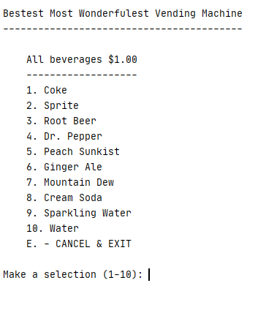

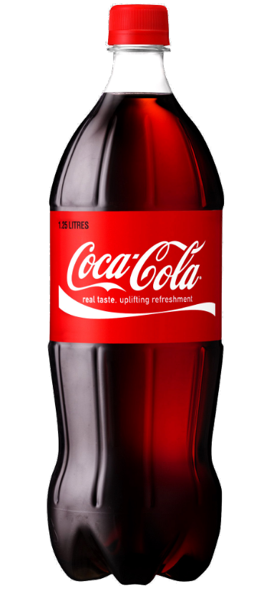Test result #2 displays the successful outcome of ensuring the user has entered sufficient funds in order to dispense the beverage. Similarly, this test result also successfully outlines that the beverage was dispensed correctly and the picture of the selected beverage was displayed accurately.

